PRODUCT REFERENCE

# Raw and sun dried tobacco

The BICON case [Raw and sun dried tobacco](http://biconnet.daff.gov.au/BICONWeb/ImportConditions/Conditions?EvaluatableElementId=283715&Path=UNDEFINED&UserContext=Internal&EvaluationStateId=4f78868b-9c8f-4c35-bf65-fba830c55cbc&CaseElementPk=820791&EvaluationPhase=ImportDefinition&HasAlerts=True&HasChangeNotices=False&IsAEP=False) applies to recently harvested tobacco that has not yet been cured, and tobacco that has been dried and cured but not yet processed for end use of smoking. Tobacco can be cured using various methods including air-curing, fire-curing, flue-curing and sun-curing (‘sundried’). Unprocessed tobacco could introduce a range of exotic plant diseases, weed seeds and storage pests and is therefore subject to biosecurity control.

This case does not apply to tobacco that is processed and packaged into a ‘ready-to-use’ products for end use of smoking. Ready-to-use products including cut rag (finely shredded tobacco), cigarettes, cigars or ‘roll your own’ products pose a low biosecurity risk and are not subject to biosecurity control.

## **Examples of unprocessed raw and sundried tobacco**

Figures 1 to 6 are examples of unprocessed raw and sundried tobacco that are subject to biosecurity control:

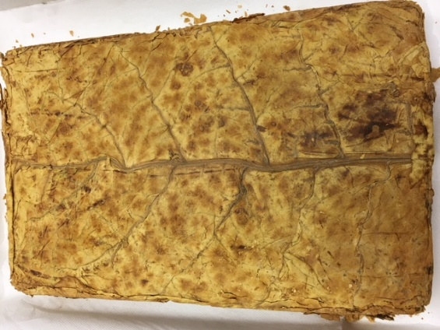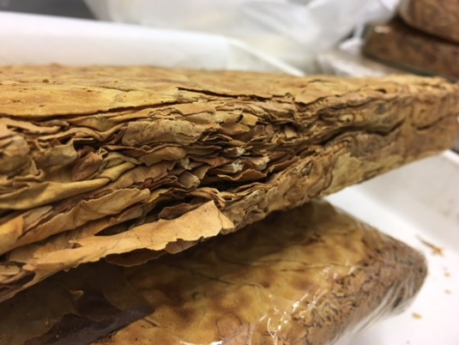

**Figure 2**

**Figure 1**

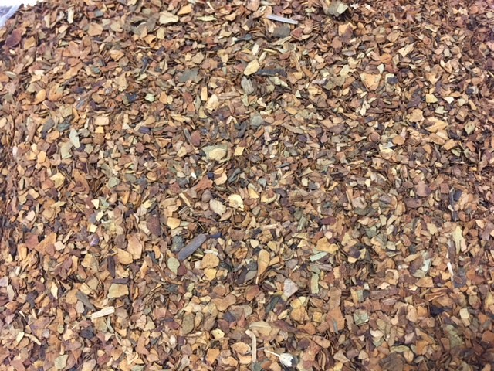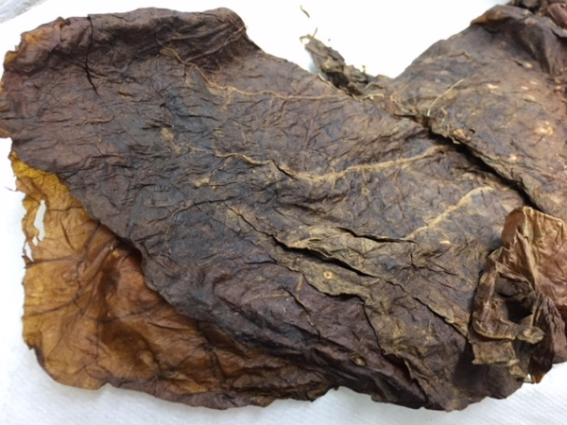

**Figure 4**

**Figure 3**

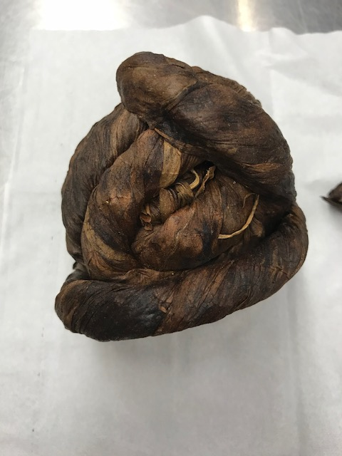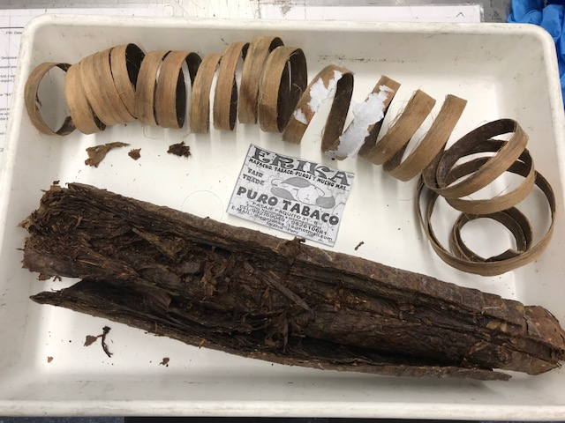

**Figure 6**

**Figure 5**

**Processed ‘ready-to-use’ tobacco products**

Figures 7 to 8 are examples of sufficiently processed and packaged into a ‘ready-to-use’ tobacco products that are not subject to biosecurity control:

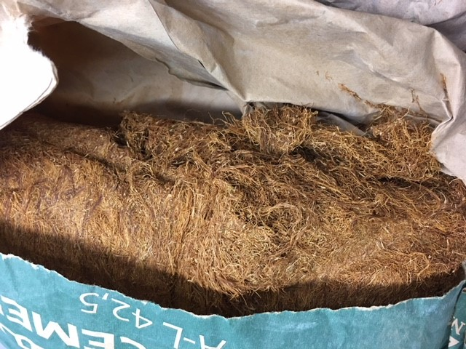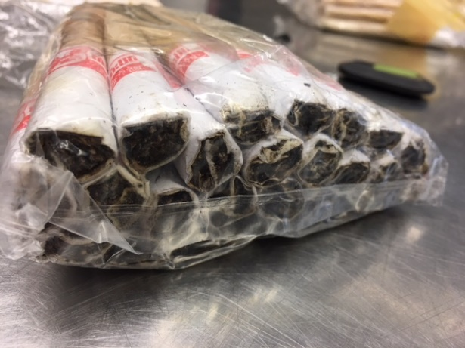

**Figure 8: Cigarettes**

**Figure 7: Cut rag (finely shredded tobacco)**