RISK BACKGROUND

Soil
Overview
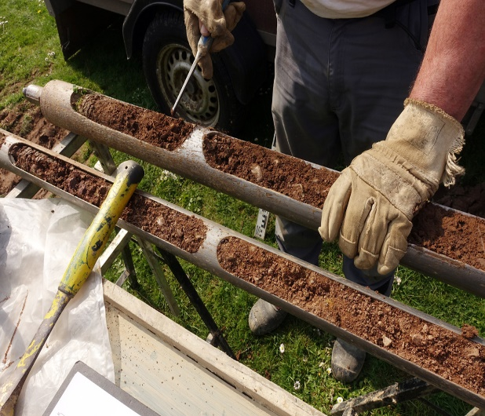  Image: : Shutterstock ID: | Soil is defined as unconsolidated material on the immediate surface (approximately top 2 metres) of the earth. Soils are aggregates of minerals, water, decomposed animal and plant material, and microorganisms.  Soil requires an import permit in most instances and the conditions placed on them depend on different factors including:  - the country of origin of the soil  - the location and description of where the soil was collected  - end use (in vivo in laboratory organisms, in vitro) and whether the soil will remain in biosecurity  - the size of each individually packaged unit.  Importers and departmental staff should always refer to BICON for the current conditions.

Key risks
Imported soil presents a significant biosecurity risk to Australia because it could be contaminated with a range of microorganisms and materials from avian, terrestrial (including humans) and aquatic animals, such as parts of dead animals, faeces, secretions and excretions. It may contain pathogens of animal biosecurity concern that could affect animals in Australia, with a number being zoonotic (i.e. have the potential to infect humans).

Some examples of the exotic diseases that could be introduced into Australia by soil include:
Foot-and-mouth disease
African swine fever
Lumpy skin disease

Foot-and-mouth disease is considered one of Australia’s biggest biosecurity risks. An uncontrolled outbreak could lead to beef, lamb and pork export markets being closed for more than a year, and control costs have been estimated at more than 50 billion dollars over 10 years. It is important that soil samples being imported for in vivo work or in vitro work involving microbiological culture or virus isolation are only sourced from countries with an acceptable disease status (i.e. do not contain pathogens of highest animal biosecurity concern or transmissible spongiform encephalopathies) unless otherwise approved by the department.

Pathogens of plant biosecurity concern may also be present in soil samples and advice should also be sought on the plant biosecurity risks.

The department uses multiple risk management measures to ensure that any biosecurity risks associated with imported goods are adequately managed to meet Australia’s Appropriate Level of Protection (ALOP), which is aimed at reducing the risks to a very low level, but not to zero. These measures may include pre-border, border and post-border import conditions, all of which are listed on the relevant permit. Applications to import soil need to include end use, country of origin, country of export, the location and description of where the soil was collected, Approved Arrangement details, and whether the presence of animal material is known.

Note: Under Australian biosecurity legislation, laboratory animals are defined specifically as a: ‘guinea pig, hamster, mouse, rabbit, rat or microorganism that is used in a laboratory’.

