PRODUCT REFERENCE

Hemp seed for human consumption or cosmetic use

What is hemp seed?
Hemp is a term generally used to describe any plant of the genus Cannabis that is cultivated purely for its fibre and seed. These types of Cannabis plant have a very low tetrahydrocannabinol (THC) content, with the leaves and flowering heads of this type of Cannabis containing 1% or less total THC. Hemp seeds are seeds from these specific types of Cannabis plants and contain no THC at all.
What is hemp seed used for?
Hemp seeds are a good source of protein, unsaturated fats and fibre and are generally eaten as a breakfast food in cereal, yogurt, smoothies or used in baking. The hemp seed in these products has had the hard, inedible outershell (hull) removed. This process is known as hulling or de-hulling and renders the seed non-viable (unable to grow). Hulled hemp may also be processed into hemp seed meal, hemp seed milk or hemp seed oil (this is different to hemp oil as it is manufactured from the hemp seed rather than the plant itself). Hemp seed oil may either be eaten similar to other edible oils, or used in the production of cosmetics.
In order to meet the Department requirements for human consumption (not for growing purposes), imported hemp seed must either be processed in a manner that renders the seed as non viable (hulled), or processed at an Approved Arrangment site (Class 3.0).
There are two methods that the Department uses to determine viability of seed:
1. A germination test result; in which a sample of the consignment is taken and germination is attempted. If the seed is not capable of germination it may be released from biosecurity control.
OR
2. An inspection of product to verify the processing level i.e. to confirm that the seed has been sucessfully hulled and therefore rendered non-viable.

Hemp seed viability
Viable form | Non Viable form
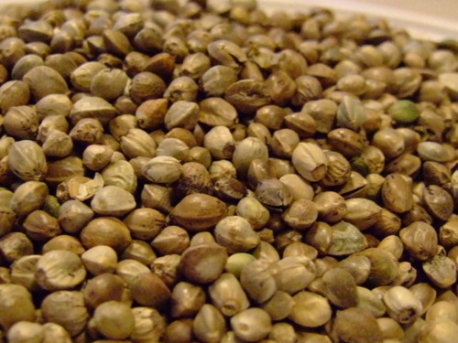  Hemp seed (with hulls intact)  Source: http://www.oilseedcrops.org/wp-content/uploads/2012/06/Hemp-Seed-Close-Up.jpg  Hemp seed with the hull intact (unhulled seed) is viable and capable of germination. | 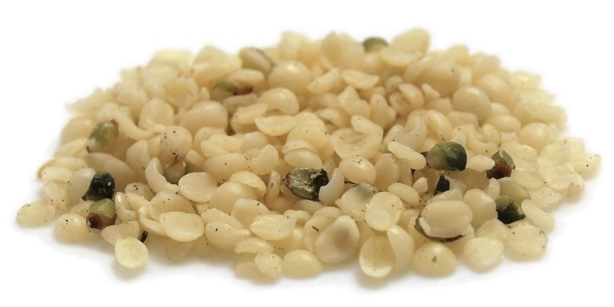  Hulled hemp seed  Source: http://www.oilseedcrops.org/wp-content/uploads/2012/06/Hulled-Hemp-Seed.jpg  Hemp seed that has gone through the process of hulling or de-hulling (having the hull removed) is not viable and no longer capable of germination

Hemp seed hulls  The inedible outer shell of hemp seed that is removed during the hulling (or de-hulling) process. | 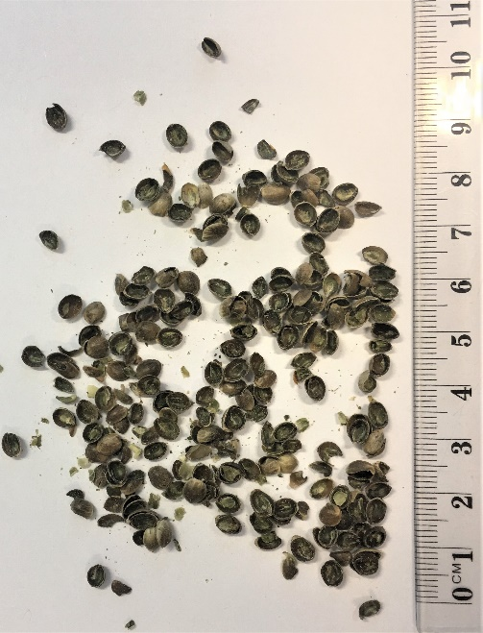

Processed Hemp Seed Products
Hemp seed meal | 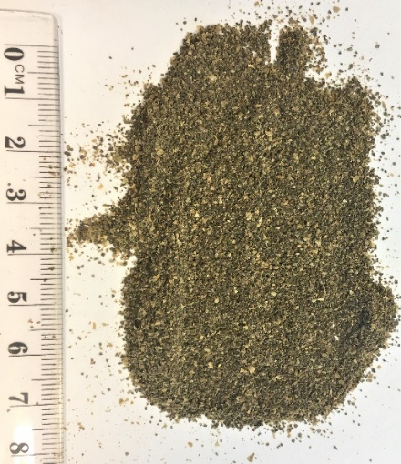
Hemp milk | 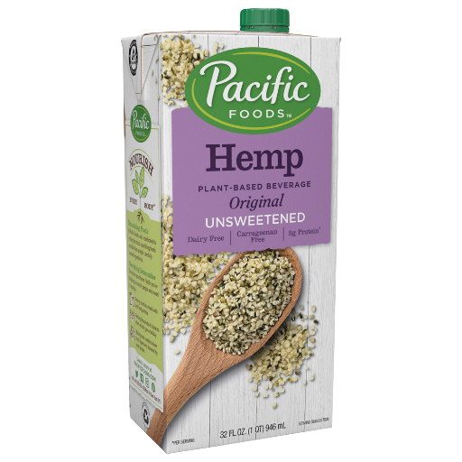  Source: https://www.pacificfoods.com/our-products/hemp-plant-based-beverages/unsweetened-hemp-original/
Hemp seed oil | 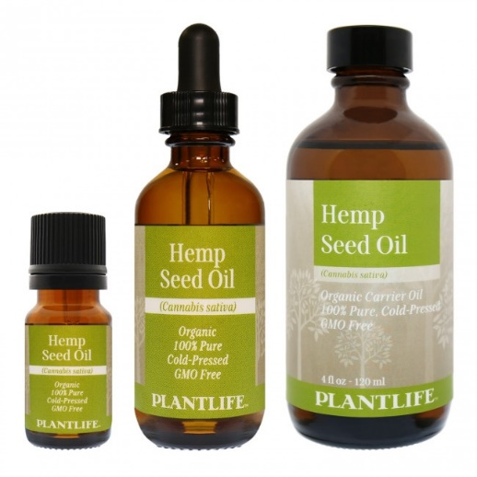  Source: https://www.plantlife.net/hemp-seed-oil.html

